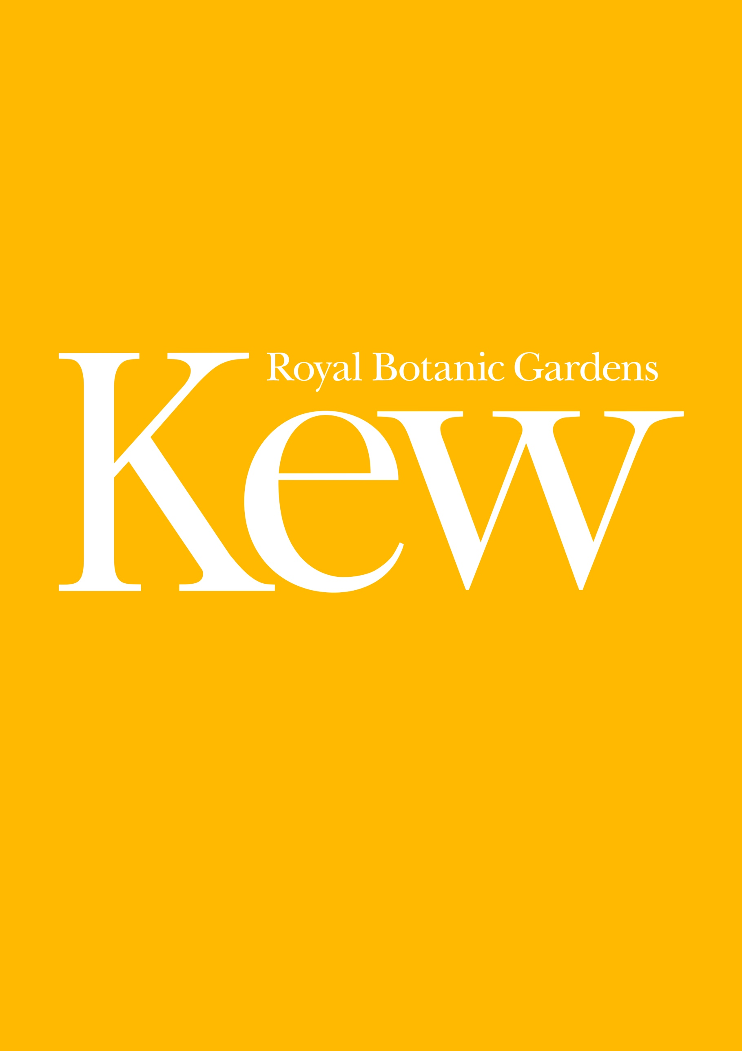
Visiting the Library, Art & Archives Reading Room
May 2021
Version – 1.0

How to find us
Directions and accessibility
Access to published materials, archives, and illustrations at the Royal Botanic Gardens, Kew is managed by the Library, Art & Archives department. Access is provided in the Reading Room which is located within the Herbarium building.
The Herbarium is situated on Kew Green, close to the ‘Elizabeth Gate’ (Main Gate on the map below) of the Gardens and access is gained without having to enter the Gardens themselves.
The full Reading Room address is: Library, Art & Archives, Royal Botanic Gardens, Kew, Surrey, TW9 3AE.
On site car parking for Reading Room visitors is not available unless required for accessibility reasons. If you require car parking, please communicate this to us during the booking process.
The Herbarium is a short walk from both Kew Bridge (national rail) and Kew Gardens (underground and overground) stations. Both routes are signposted. The Herbarium can also be reached by several buses including the 65, 391, 237 and 267. There is wheelchair access to the Reception of the Herbarium building and the Reading Room, and a wheelchair accessible toilet in the Reception and Reading Room.
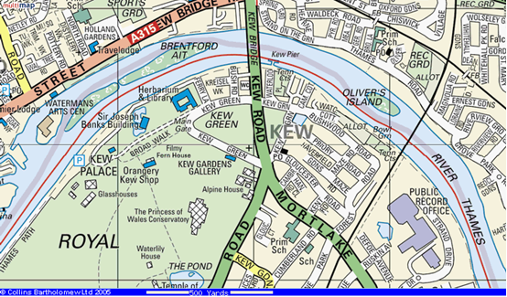
Contacting us
If you need to contact us on the day of your visit, please call: 0208 332 5429.
For any changes to your appointment prior to the actual day of your visit please email the relevant collection (e.g., library@kew.org, archives@kew.org).
What to bring
- Identification
On your first visit to the Reading Room (or if you have not visited for over 2 years) you will need to show photographic identification such as a passport or driving licence, as well as proof of address such as a utility bill.
- Face covering
We ask that all visitors to the Reading Room wear a face covering unless they are exempt.
- Hand sanitiser
Please note that hand sanitiser is provided throughout the building and is not permitted within the Reading Room itself.
- Pencil
The Reading Room operates a ‘pencil only’ policy and pencils are made available for use.
- Water bottle
No liquids are permitted within the Reading Room itself nor food of any kind, including sweets or chewing gum. You are welcome to return to the Reception area to take a drink.
- Camera
You are welcome to take your own photographs without flash on completion of a self-service photography form available from the information desk.
On arrival
We are doing all we can to help everyone feel safe when visiting the Reading Room, but we need your help too. We ask that all visitors behave responsibly and respect the measures that we have put in place. These measures are to ensure the protection and safety of all our visitors and staff.
Enter the Herbarium through the black metal gates (these will be unlocked), turn right and follow signage to the Reception. The glass doors to the Reception area are currently kept closed – please alert the Receptionist to your presence through the glass and they will release the doors for you to enter.
All visitors are asked to wear a face covering throughout their visit unless they are exempt. If you have a legitimate reason not to wear a face covering, please indicate this during the booking process – this will help our staff prepare for your arrival and ensure that your visit is not delayed. If you need to lipread, please advise our staff and they will remove their face covering at a safe distance.
You will be asked to sign a register and to leave bags and coats in a secure locker in the Reception area. Laptop bags are not permitted in the Reading Room, although you may bring in a clear plastic bag. The lockers require a one pound or one Euro coin (which will be returned to you) or you can borrow a token from Reception. All liquids should be left in the lockers (including water and hand sanitiser).
From Reception you will be directed to the Reading Room on the first floor (a lift is available).
On entering the Reading Room, you will be directed to wash and thoroughly dry your hands before and after handling items. The use of hand sanitiser is not permitted, and no liquids should be brought into the Reading Room itself.
Read and follow the handling guidelines as noted at your desk (see also the Handling guidance section below).
Please do not consult the books on the shelves within the Reading Room. If you wish to view any library works these should be ordered in advance of your visit (please contact library@kew.org). The library catalogue is available online

Documentation for your visit
Visitor’s Registration Form
Please complete a Visitor’s Registration Form if this is your first visit to the Reading Room (this will be sent to you via email, copies will also be available at the information desk).
The Registration form does not entitle the bearer to free entry to the Gardens.
The Reader’s Sheet
Readers’ sheets are created as a reference for both readers and staff, detailing the items you are consulting.
On this sheet, the references to the material you reserved will be given, sometimes with the relevant folios (pages) as required.
You are free to take the readers’ sheet away with you for your records.
There is a limit of ten documents/items per day, although some flexibility may be permitted.
We cannot accommodate requests for access to additional materials on the day.
Archives Document Retrieval Slips
Each archival item made available to you will have a corresponding document retrieval slip.
Readers are asked to sign and date each slip as they view the material and place the slip back with the archive item.

What to expect
Rather than issue items individually all requested items will be available at your table at once on a trolley.
At present we are providing up to 10 items per reader, per day. We cannot facilitate the retrieval of items on the day.
Please:
- take items off and return them to the trolley/s yourself but avoid touching the trolley handles.
- take and consult one item at a time where possible, returning items to the trolley when not consulting.
- ensure you do not have more than one Archive or Illustration item (e.g., 1 box, 1 folder) on the desk at a time, where possible.
- do not stack items on top of each other precariously.
- maintain the order of items in files/boxes and do not mix items from different files or boxes together.
At present we are not able to offer an information desk enquiry service. Desk staff will do their best to assist you from a safe distance, but you may have to direct your enquiry via email to the relevant collection service (e.g., library@kew.org).

Handling materials
Gloves are provided for handling photographic or glass material where necessary.
Please use all supports and book weights provided on your trolley.
Take items off and return them to the trolley/s yourself but avoid touching the trolley handles.
Take and consult one item at a time where possible, returning items to the trolley when they are not being consulted.
Do not stack items on top of each other.
Try not to touch items more than necessary. Use the paper markers provided instead of fingers to follow text, and as bookmarks.
We recommend that all visitors take time in advance of their visit to view the following video handling guidance provided by the British Library. Good handling practice is essential to ensure the continuing preservation of Library, Art & Archives material.

How to handle books (4 minutes)
When handling bound items:
- take the time to check you are supporting books adequately
- use the book supports in a way that suits the book – adjust the supports or add more as needed
- have tools and equipment to hand and enough space to work in

How to handle prints, drawings, and photographs (4 minutes)
This video includes advice on handling:
- prints photos
- loose prints and drawings
- mounted prints and drawings
- photographs in protective sleeves
- unprotected photographs
- photograph albums

How to handle Archives (4 mins)
This video includes advice on handling:
- unbound documents
- treasury tags
- paper clips
- post binders
- bound documents

Finishing your visit
When you have completed your visit, please return all collection items, paperwork and supports to the trolley/s, leaving the trolley in situ.
Use hold slips (available from the information desk) to note any items that you would like to consult again. Items can be held for up to 2 weeks. All other items will be quarantined and returned to the shelf.
Notify desk staff that you are leaving the Reading Room.
Wash and dry your hands.
Return to the Reception, returning any locker key to the Receptionist.
Note your time of departure in the Reception register.

Thank you for your time and we hope that you enjoy your visit

