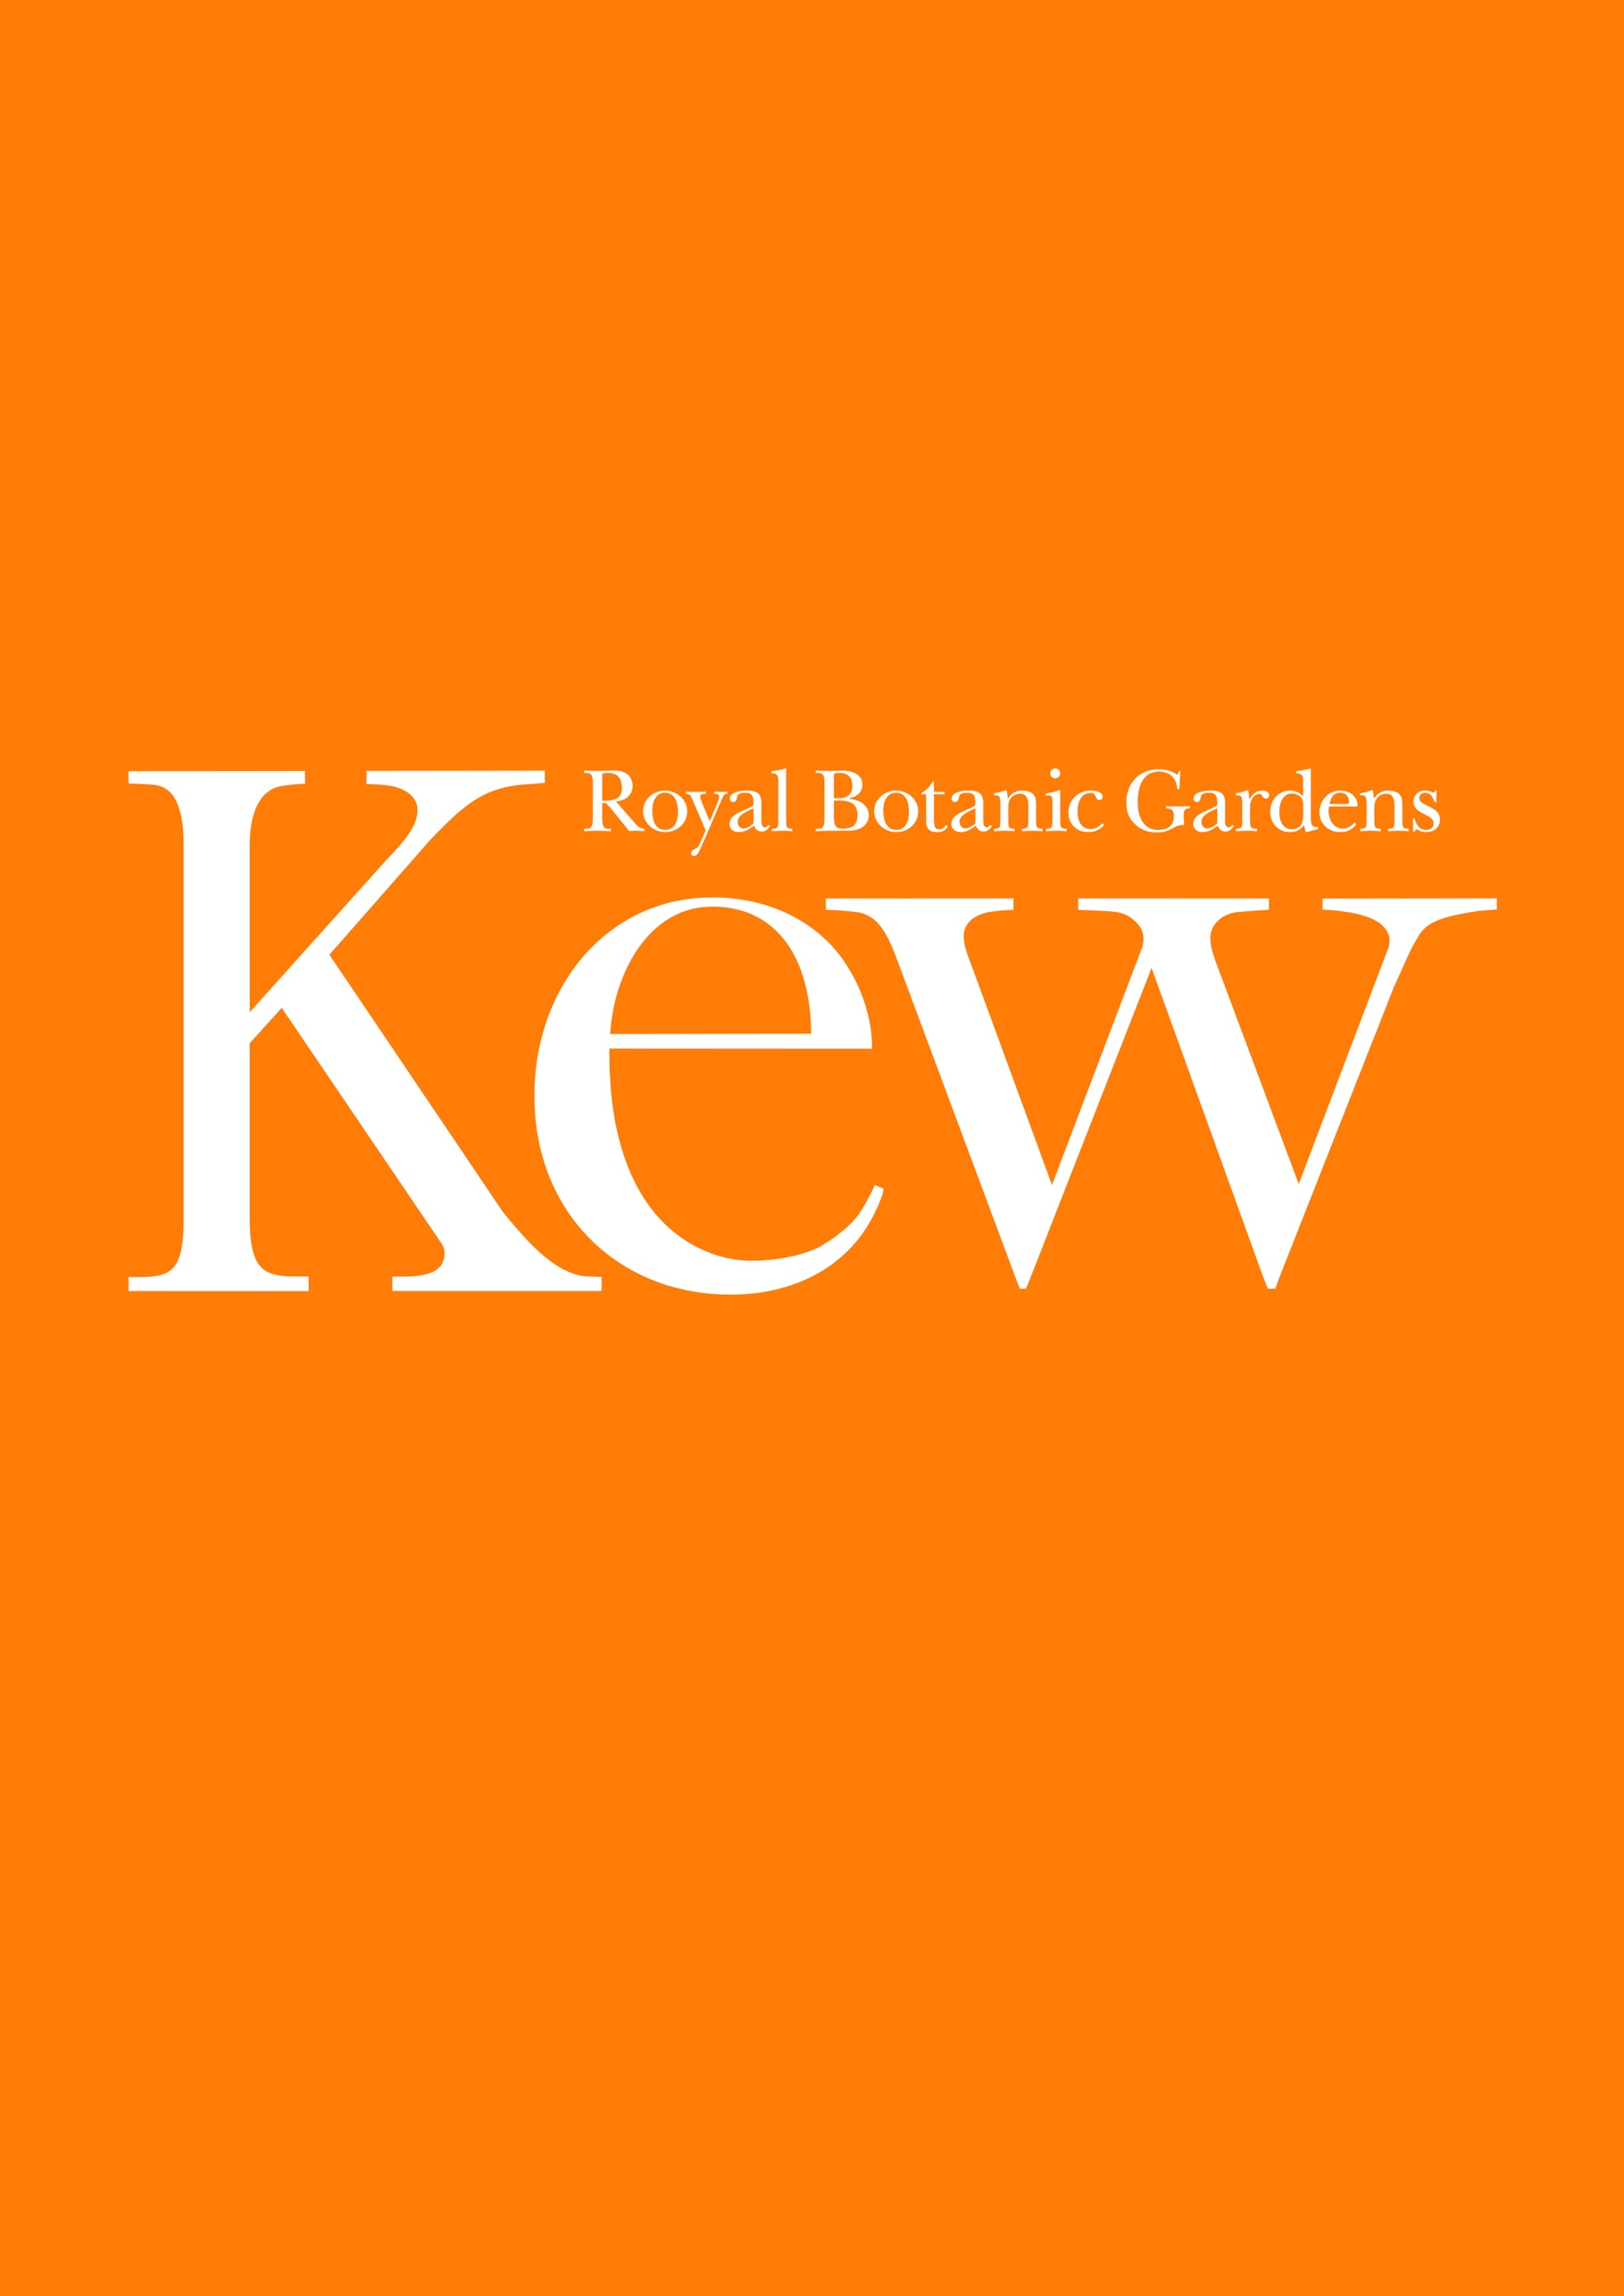
Privacy notice for suppliers
A subheading would be here
Date – 28th November 2019
Version – 1.0

Who we are
“Kew” refers to the following three separate entities:
- Royal Botanic Gardens, Kew (“RBG Kew”): RBG Kew’s full name is “The Board of Trustees of the Royal Botanic Gardens, Kew”. RBG Kew is a non-departmental public body with exempt charitable status
- The Foundation and Friends of the Royal Botanic Gardens, Kew (“The Foundation”): The Foundation is a registered charity with charity number 803428, and its object is to provide support for RBG Kew, by undertaking legacy fundraising.
- RBG Kew Enterprises Limited (“Enterprises”): Enterprises is a company (with company number 02798886) and is a wholly owned trading subsidiary of RBG Kew
We refer to these three entities collectively as “Kew” throughout this Privacy notice, and references to “we” and “us” refer to the Kew entities collectively.
The RBG Kew Procurement Team is responsible for procurement strategy and policy and supports Kew to undertake procurements and manage contracts awarded. RBG Kew will process personal data as data controller for the purposes of tendering and administering procurements and contracts awarded for the benefit of RBG Kew, Enterprises and The Foundation. If the procurement and contract award benefits Enterprises and The Foundation, they may also each be data controllers of personal data for those purposes.
RBG Kew’s address is Royal Botanic Gardens, Kew, The Herbarium, Kew Green, Richmond TW9 3AE.
The Foundation and Enterprises are both based at the Royal Botanic Gardens, Kew and have offices at 47 Kew Green, Richmond TW9 3AB.

What personal data we collect and the purposes for which we use it

What personal data do we hold?
Personal data we may collect and hold as part of the procurement and contract award process may include name, work contact information including postal address, telephone number, email address; records of your correspondence with us; CV and similar information about the skills and experience of key personnel involved in the delivery of the contract; references and other information related to the procurement.

How and why we use this personal data
We will use personal data for the purposes of tendering new contracts and to inform plans for commercial negotiations with suppliers, in order to carry out our statutory responsibilities under the Public Contracts Regulations 2015 and in compliance with our procurement strategies to secure value for money on all procurements whether or not regulated by the Public Contracts Regulations.
This may include processing to communicate with the bidding organisation (and potential bidding organisations) as part of the procurement process; to evaluate bids and carry-out the required due diligence on bidding organisations; to keep a record of the procurement process and our relationship with the bidding organisation; to carry out any background checks (such as credit checks) on the bidding organisation; and if you are a self-employed trader, your UTR number in order to confirm that you are registered with HMRC for self-assessment tax purposes.
We may also collect and process personal data for service improvement and planning; prevention and detection of crime/fraud; research; statistical analysis and reporting; all related to the procurement service.

Automated decision making and profiling
Kew does not use personal data for automated decision-making which produces legal effects or similarly significantly affects individuals.
What lawful bases do we rely on to use personal data?
The legal bases that we rely on for processing personal data in connection with procurement are:

It is necessary for compliance with a legal obligation to which we are subject
This would include where we have a legal obligation under UK legislation including the Public Contracts Regulations 2015; Bribery Act 2010; where we must retain certain records, for example, for the detection and prevention of crime/fraud.

It is within our legitimate interests
Applicable law allows personal data to be collected and used if it is reasonably necessary for our legitimate interests or a third party’s legitimate interests (as long as the processing is fair, balanced and does not unduly impact individuals’ rights). We will rely on this ground to process personal data where we are confident that this will not impact the individual’s rights.
How we collect personal data
We collect information when either the individual or the bidding organisation gives it to us in connection with a procurement process.
Data sharing
We do not sell personal information obtained in connection with a procurement process under any circumstances.
RBG Kew, Enterprises and the Foundation may share personal data between themselves, so if you give your information to RBG Kew then this may be shared with Enterprises and the Foundation, for example. However personal data will only be shared between the entities for purposes related to the procurement process.
We work with service providers and other third parties who provide services and support to us to run our daily operations, including our IT networks and we may share information with them for these purposes only.
processed by organisations or companies outside the European Economic Area (“EEA”). Where personal data is transferred outside the EEA, we will take reasonable steps to ensure that the recipient implements appropriate measures to protect the personal data (for example, by entering into EU Commission approved standard contractual clauses).
Unfortunately, the transmission of personal data via the internet is not completely secure. Although we will do our best to protect personal data, we cannot guarantee the security of personal data transmitted to or via our websites and digital products. If you have any questions about the international data transfer of your personal data, please contact us using the details below in section 10.

Lorem ipsum dolor sit amet, consectetur adipiscing elit. Quisque efficitur dapibus eros sit amet consectetur. In at vulputate turpis. Nullam molestie mi quis urna sollicitudin posuere. Sed ac nisl eu nibh ullamcorper sagittis sed fermentum mauris. Nulla ultricies sed neque ut semper. Nam vitae sapien nisi. Curabitur volutpat lectus in elit luctus mollis:
• Bulleted list
• Bulleted list
1. Numbered list
2. Numbered list
3. Numbered list
a. Numbered sub-list.
b. Numbered sub-list
c. Numbered sub-list
* Footnote
Subheading
Lorem ipsum dolor sit amet, consectetur adipiscing elit. Quisque efficitur dapibus eros sit amet consectetur. In at vulputate turpis. Nullam molestie mi quis urna sollicitudin posuere. Sed ac nisl eu nibh ullamcorper sagittis sed fermentum mauris. Nulla ultricies sed neque ut semper. Nam vitae sapien nisi. Curabitur volutpat lectus in elit luctus mollis:

Whilst we may allow our staff, consultants and/or external service providers acting on our behalf to access and use your personal data for the activities we have described in this policy, we only permit them to use it for the purposes described in this Privacy Notice, and only if they apply an appropriate level of security protection.
Sharing for regulatory or legal reasons. We may need to disclose personal data upon request to regulatory and government bodies as well as law enforcement agencies. We may also merge or partner with other organisations and in so doing, acquire or transfer personal data but personal data would continue to be used for the purposes set out above.
Transmission outside of Europe or via the Internet. The personal data we collect may be transferred to, shared and/or otherwise
Unfortunately, the transmission of personal data via the internet is not completely secure. Although we will do our best to protect personal data, we cannot guarantee the security of personal data transmitted to or via our websites and digital products. If you have any questions about the international data transfer of your personal data, please contact us using the details below in section 10.
How we keep your personal data safe and who has access to it
We are committed to ensuring that there are appropriate technical controls in place to protect personal data including protection from misuse and unauthorised access. For example, our network is protected and routinely tested.
Personal information is only accessible by staff, volunteers and contractors who are bound by appropriate policies and procedures to protect the information.
Your rights
Individuals have various rights concerning the processing of their personal data (for more information, we suggest that you consult guidance from the Information Commissioner’s Office (ICO) – https://ico.org.uk/for-organisations/guide-to-the-general-data-protection-regulation-gdpr/individual-rights/ - or contact us using the details in section 10.
However, exercising your rights in a manner which impairs the procurement process or subsequent contract may result in exclusion from the procurement process.
Complaints
If you are unhappy with the way in which we have handled your personal data, please contact us using the details below.
Please let us know if you have any queries or concerns about the way that your personal data is being processed by us by contacting us on the details below. You are also entitled to make a complaint to the Information Commissioner’s Office. For further information see the Information Commissioner’s guidance here: https://ico.org.uk/for-the-public/personal-information.
Data retention
We keep personal data for as long as there is a need to keep it in connection with the purposes for which it was collected. We may keep personal data after a procurement process has concluded but purely for record keeping purposes and to be able to respond to queries. In some cases, we are also obliged to retain personal data to comply with legal or statutory obligations (for example, to keep records of contractual or financial matters).
Whilst the specific time periods vary depending on the circumstances, in general we will not keep procurement related records that include personal data for more than 10 years after the procurement has concluded.
Contact
For all enquiries in respect of this privacy policy, please contact privacy@kew.org or The Data Protection Officer, The Royal Botanic Gardens, Kew, Richmond, TW9 3AE.
Changes to this privacy notice
We keep our privacy notices under regular review.

